The Cell Cycle

Remember:
There are 3 basic reasons why a cell divides. 1) to _____________________________________

2) to _____________________________________ and

3) to _______________________________________

Remember: What these organelles do 1) nucleus _____________________________

2) cell membrane _______________________

Where we find chromosomes ___________________________________ and

What chromosomes do _________________________________________

What are some other organelles? ________________, ____________________

__________________ and _________________________

The cell cycle = the _______ stages a cell goes through as it grows and divides (into 2)

1. Interphase = _______________________________________ and

________________________________________

2. mitosis = __________________________________________ (PMAT)

3. cytokinesis = _______________________________________
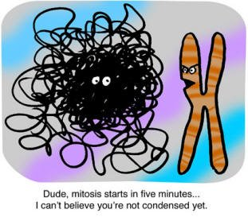

Memory trick: ‘inter’ means _______________________

‘cyto’ sounds like ________________________________

Extra: deoxyribonucleic acid = __________(chromosomes)
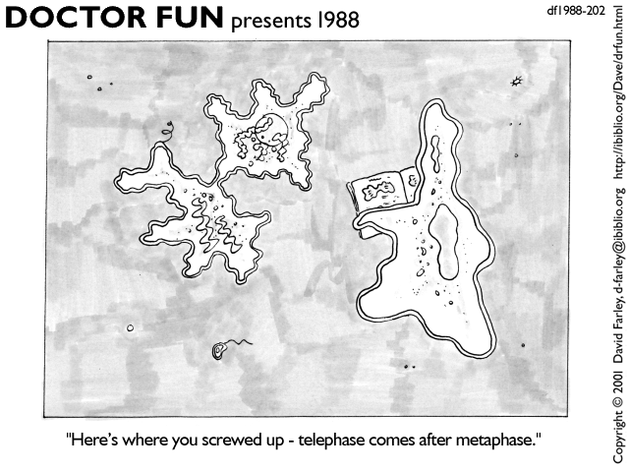
Modelling Mitosis - modeling mitosis helps you learn it! There are 4 stages of mitosis.

CREATE the stages with plasticene. DRAW in the result.

Interphase – at the end, all the chromosomes doubled

Prophase – The chromosomes thicken. On plasticene sheet, draw a nucleus that will fit 3 chromosomes. Create 3 doubled, thick chromosomes – each a different colour. Put them inside the nucleus. Label ‘chromosomes’ and ‘chromatid’. (see the front board).

Metaphase – the nucleus disappears (erase it).
Now the doubled chromosomes line up in
the middle of the cell.
Attach some spindle fibres. (see front board). Label ‘spindle fibres’.
Memory trick – metaphase <-> middle

Anaphase – The doubled chromosomes separates and one chromatid goes to one end of the cell and the other (sister) chromatid goes to the other end. Draw in spindle fibres pulling
Chromatids apart

Telophase – a nucleus forms around
each set of chromosomes. Draw this in. Label the nucleus.
Teacher Notes:

Draw a doubled chromosome on board, labeling ‘chromosomes’ and also ‘chromatid’.

Show on the board that the chromosomes go to separate sides of the cell to a ‘point’ (centriole). Spindle fibres ‘reel in’ the chromosomes. Show home to draw spindle fibres.

